人物类型
- 重要的好朋友（新增）
Describe a good friend who is important to you
You should say:
Who he/she is
How/where you got to know him/her
How long you have known each other
And explain why he/she is important to you
- 擅长音乐的朋友（新增）
Describe a friend of yours who is good at music/singing
You should say:
Who he/she is
When/where you listen to his/her music/singing
What kind of music/songs he/she is good at
And explain how you feel when listening to his/her music/singing
- 由不喜欢到喜欢的朋友
Describe a person you disliked at first but ended up being friends with
You should say:
Who he/she is
How you knew him/her
Why you disliked him/her at first but changed your mind
And explain how you feel about the experience
- 会打扮的朋友
Describe a friend of yours who is well dressed and is good at dressing up
You should say:
Who he/she is
How you knew him/her
What his/her dressing style is
And explain why he/she dresses this way
- 发小
Describe a friend from your childhood
You should say:
Who he/she is
Where and how you met each other
What you often did together
And explain what made you like him/her
- 着装特殊的人
Describe a person who you think wears unusual clothes
You should say:
Who this person is
How you knew this person
What his/her clothes are like
And explain why you think his/her clothes are unusual

So, let me talk about my best friend Yvette.she's actually this super outgoing girl, and we've been besties since we were very young. Literally, I remember knowing her when I was 3 because our parents are BFFs, so we grew up hanging out all the time.

But here's the thing: I used to not like her at all. Why? 'Cause our parents kept comparing us. Andy was like this all - rounder—super cheerful and crazy talented. First, music—she's a piano wizard. At 6, she won the city piano competition. I still remember her playing at that age, so confident!

And her style? Totally unique. When I was forced to wear boring clothes my mom bought, she was already mixing bright colors like a pro. In primary school, even in uniform, she'd stand out with a funky hair clip or a colorful headband. On weekends, she'd rock the trendiest outfits—think neon sneakers with floral dresses, but it never looked messy, just cool.

The reason she dresses in vibrant colors is that she believes it creates a positive vibe for herself and those around her. Picture this: when you're feeling down, she comes over like a little sunshine—wearing an orange hoodie and light-colored jeans—jumping around to cheer you up, instantly brightening your mood through her cheerful presence.

But get this—even when I was being petty and jealous, she was always chill. We've known each other for 17 years now, can you believe it? Now she's my go - to person for everything. Like, she taught me piano. "Dude, your fingers are perfect for this," she'd say, then play a song first to show me. Her playing is so calming—like, when she plays, it's like all my stress melts. And she's so patient, never gets annoyed if I mess up.

Also, when I'm confused about what to wear, she's my stylist. She knows my body better than I do! "Wear that flowy dress, it shows off your height," or "Try wide - leg jeans, they'll make your legs look longer." Her tips always work.

Looking back, I used to dislike her because I felt insecure next to her. But now, she's not just a friend—she's like family. She's taught me more than piano or fashion; she made me less shy, more confident. I mean, how many people can say their childhood friend turned into the person who shaped who they are? She's definitely the most special person in my life.
（来说说我的闺蜜 Yvette 吧。她性格超级外向，我们从穿开裆裤就混在一起。严格讲，3 岁我就认识她了——咱爸妈是铁瓷，于是我们俩也天天被绑在一起。
但神奇的是，我小时候一点儿都不喜欢她。为啥？因为长辈老拿我俩做对比。Yvette 就是那种“别人家的孩子”，阳光、全能、开挂。先说音乐：她弹钢琴像开了外挂，6 岁就把市里的钢琴比赛一等奖抱回家。我到现在都记得她当时在台上那自信的小表情！
再聊穿搭——她简直天生会玩色彩。我妈还逼我穿批发款 T 恤时，人家已经把荧光绿配玫红玩得溜溜的。小学统一校服，她也能用一枚搞怪发夹或一条亮色发带瞬间出圈；周末更夸张，荧光球鞋配碎花裙，居然一点都不乱，只剩一个“潮”字。
她之所以把调色盘穿身上，是因为她觉得鲜艳的颜色能给自己和周围人充电。想象一下：你正丧着，她穿着橙色卫衣、浅牛仔“哒哒哒”蹦跶过来，像颗小太阳，瞬间把你的乌云吹散。
更绝的是——当年我小心眼儿吃醋，她却始终淡定。一晃 17 年过去了，现在她成了我的万能外挂。比如学钢琴，她说：“哥，你这手指天生适合爬键。”先自己示范一遍，指尖一出声，我的压力就像被熨斗烫平。她耐心满格，我弹错 800 次她也不炸毛。
再比如出门纠结穿搭，她直接变身造型师，比我还懂我的身材：“穿那条高腰阔腿裤，腿长两米八！”“碎花雪纺裙走起，仙气拉满！”——听她的，从没踩雷。

回头看，小时候讨厌她，其实是因为自卑。如今她早已不是“别人家孩子”，而是我户口本外多出的那位家人。她教会我的何止钢琴和穿搭，她把我从社恐怂包调成半自信模式。有几个人能说“我发小塑造了我”？Yvette 就是我人生里最特别的存在。）
- 精力充沛的人
Describe an energetic person that you know
You should say:
Who this person is
How you knew this person
Why you think this person is energetic
And explain how you feel about this person
- 聪明的人
Describe an intelligent person you know
You should say:
Who this person is
How you knew this person
What this person does
And explain why you think this person is intelligent
- 侍花弄果之人
Describe a person you know who loves to grow plants (e.g. vegetables/fruits/flowers etc.)
You should say:
Who this person is
What he/she grows
Where he/she grows them
And explain why he/she enjoys growing plants
植物和花的名称
Carnation：康乃馨 daisy：雏菊 forget - me - not：勿忘我 lily：百合花 sunflower：向日葵 tulip：郁金香 cactus：仙人掌

- 聊得来的有趣老人
Describe an old person who has an interesting life and you enjoy talking to him/her
You should say:
Who this person is
Where he/she lives
What his/her life is like
What you like to talk about with him/her
And explain why you enjoy talking to him/her

Let me tell you about this really interesting old guy. We get along so well and have great conversations. I first came across him on Douyin because he loves recording his daily life. One day, I stumbled upon his video about how to take care of jasmine plants. At that time, I'd just bought a jasmine plant, but it started wilting two days later. So I searched online for solutions and somehow found his video.

In the video, he shared lots of clever tips. For example, he taught us how to tell basic problems just by looking at the leaf color and the stem condition of the plant. He even made up a catchy rhyme to help us remember! I thought he was so smart to turn complex biology knowledge into a song. So I left a comment, and guess what? He replied to me! That’s how gardening became our common topic. I love growing plants and flowers, but I’m not good at it, so I often ask him for advice. He’s taught me so many useful things.

As we got to know each other better, I found out he’s 68 years old, but you’d never guess his age! He looks so energetic and young, with not a single gray hair. He’s also really open-minded about life. Later, I learned he lives in downtown Shanghai. To follow his passion for gardening, he turned his small balcony into a mini garden. He even told me he plans to go on a cycling trip to Tibet! I really admire his courage and energy. It’s amazing that at 68, he’s still cultivating so many hobbies and challenging himself.

He’s incredibly smart, too. While chatting, he told me about his younger days. He graduated from Shanghai Jiao Tong University, majoring in economics and ranked first in his grade for four straight years. But after graduation, he realized he wasn’t interested in the field, so he switched to study law and became a lawyer. Even after getting his master’s degree, he found he didn’t love being a lawyer either. He’s clearly super intelligent and eager to learn. But he’s also wise enough to know what he really wants. In the end, he decided to take over his family’s business (he didn’t tell me much about that). He always says life shouldn’t have too many limits. Even at 68, he feels young and wants to try more new things.

Honestly, it feels so weird. His life story is just like something out of a novel. But when we chatted, everything he said sounded totally real. So yeah, he’s the smartest, most unusual person I’ve ever met in my totally boring life so far.
His screen name’s Plain Life.

（我来给你讲一个特别有趣的老头儿。我们特别聊得来，每次对话都特别开心。我最初是在抖音上刷到他的，他特爱拍自己的日常。有天我刷到他讲怎么养茉莉，巧了，我前脚刚买回一盆茉莉，结果两天就蔫了。我上网搜办法，不知怎么就点进了他的视频。
视频里他支了好多妙招。比如光看叶子颜色和杆子状态，就能判断毛病出在哪。他还编了段顺口溜，念着特别溜！我当时就觉得，这人太厉害了，能把复杂的植物知识唱成歌。我留言夸他，你猜怎么着？他居然回我了！从那以后，养花就成了我们的接头暗号。我虽爱种花却总养死，老向他求救，他教我的东西都特管用。
混熟了才知道，人家已经68岁了，可根本看不出！精气神儿足得吓人，一根白头发都没有。思想也特潮。后来他告诉我，他住上海市中心，为了过瘾，把自家小阳台整成了迷你花园。他还说打算骑车去西藏！我真心佩服这勇气和体力，68了还不停种草新爱好、给自己上难度。
老头儿脑子也灵光。聊天时他提起，年轻时上交大经济系，连拿四年年级第一。结果毕业发现对这行没爱，又转头读法律当了律师。可硕士读完，他还是不爱这行。智商高、学习狂，却也清楚自己到底要啥。最后他回家接手了自家生意（细节没多说）。他总说，人生别设太多框，68了也觉得自己还小，想继续尝鲜。）
- 喜欢共度时光的人
Describe someone you like to spend time with
Who this person is
How you knew him/her
What you usually do together
And explain why you like to spend time with him/her

Let me talk about my best friend. I really enjoy spending time with her. Her name is Yvette, and she's a super cheerful girl. We met at a club activity when we were university classmates. After adding each other's contact info, we were surprised to find out we're from the same hometown. And we also realized we share tons of hobbies. For example, we both love chasing stars. So we usually go to offline check-in spots together to take photos. Sometimes we go to concerts, shout for our favorite stars, and enjoy their performances. Other times, we might travel to places where our idols have been. Like last week, we went to Qingdao and followed the exact travel route of our favorite star.

Among all my friends, I love hanging out with her the most. Even if we just meet, sit down for a meal, and chat, I feel really comfortable. That's because she's super tolerant and cheerful. Whenever I'm in a low mood or want to give up the trip and go back to the hotel to rest because I'm tired during travels, she always comforts me with gentle words. Amazingly, with her persuasion, I can gradually calm down and get back to facing difficulties or solving problems. She's someone with a stable core, and she's both gentle and strong.

Being with her, I feel like I can learn many good qualities and abilities from her. Like dealing with problems calmly when facing difficulties, or holding on a bit longer when I want to give up. These are things I can't learn from others.
（来说说我的闺蜜 Yvette吧，跟她待在一起简直是我最大的充电方式。她人超极阳光，我们是大学同学，社团招新那天对上眼，扫码加好友才发现——居然是同一个小县城出来的！更夸张的是爱好 99% 重合，尤其一起追星的节奏完全同步。于是我们日常就是：蹲线下打卡点拍同款照片、冲演唱会喊破嗓子、或者干脆照着偶像走过的路线来趟圣地巡礼。比如上周刚去青岛，把爱豆 vlog 里的店一家家吃过去。
在所有朋友里，我最爱黏的就是她。哪怕什么都不做，找家店坐着边吃边唠，我都能舒服到毛孔全开。她情绪稳定得像恒温空调，性格软萌却自带“托底”功能。旅途中我一旦电量告急、想打退堂鼓，她就用那种温柔但有力的语气慢慢把我“哄”回满血。神奇的是，每次被她拍拍肩膀、碎碎念几句，我居然真能平静下来，然后咬牙继续通关。
跟她混久了，我偷偷学了她好多隐藏技能：遇事先冷静拆招，想放弃时再咬牙多撑五分钟——这些课本没人教、别人也学不来的真·外挂，全被她手把手传给我了。）
- 不同文化的朋友
Describe a person from a different cultural background with whom you enjoy spending time
You should say:
Who he/she is
Where he/she is from
Where/how you knew him/her
And explain how you feel about him/her

- 喜欢的歌手
Describe a singer you like
You should say:
Who he/she is
What his/her personality is like
What kind of style his/her music belongs to
And explain why you like him/her
（On top of that, he’s achieved a lot too. Him and his group have performed on the Grammy stage more than once. I’m not really sure if they actually won a Grammy or not, but for a K-pop group, just getting to perform there is already a huge achievement.）

Let me tell you about my "one - sided" friend, who's actually a famous star. His name is Jungkook, and he's from South Korea. He always says that his fans are his friends, so I like to think of us that way, even though we're from different countries and cultures.

I first discovered his music on Douyin . His songs blend different styles like R&B and rock with unique Korean elements. You can hear Korean singing styles in his music, and his lyrics often show Korean clothing and traditions.

We "chat" on a messaging app because he sometimes goes online to interact with fans. China and Korea have some cultural similarities since Korea had historical ties with China. And unlike some who mix up cultural origins, Jeon Jungkook is really straightforward. Once during a live stream, when a friend said noodles were invented by the Japanese, he firmly said they were Chinese and even mentioned he loves Chinese beef noodles.

He also shares Korean culture through his music and chats, teaching us about Korean clothes and customs. And we get to tell him about Chinese culture, like our traditional clothes and food. To me, he’s not just a star I admire; he’s like a friend who helps me learn about another culture while we bond over music.

The celebrity I really like is Jeon Jungkook from South Korea.

First, let's talk about his personality. He's super kind and genuine. He often interacts with fans online, sharing his daily life and thoughts. Also, he's very respectful, especially when it comes to cultural issues. Once, someone wrongly said noodles were invented by Japanese people during a live stream, but he firmly corrected that noodles are from China and even praised Chinese beef noodles.

Now about his music style. It's really unique! He mixes different genres like R&B and rock with Korean elements. You can hear special Korean singing styles in his songs, and his lyrics sometimes show Korean culture, like their traditional clothes.

I like him because his music is so creative and catchy. Also, his good personality makes him more than just a star to me. He helps me learn about Korean culture through his work, and I admire how he respects different cultures.
（让我来介绍一下我的“单向”朋友——韩国人气明星田柾国（Jungkook）。他总把粉丝称作朋友，所以我也就悄悄把我们算进“好友列表”了，尽管我们隔着国家、文化，还隔着屏幕。
第一次听见他的歌是在抖音。他的作品把 R&B、摇滚和韩国传统元素搅在一起：旋律里能抓到韩式的转音，歌词里会跳出韩服、佳节、市井烟火。只要耳机一戴，就像被瞬移到首尔的小巷。
我们“聊天”靠一款社交软件——他偶尔会上线翻牌、读留言。中韩文化有不少相通之处，历史上也往来频繁。田柾国在“文化原产地”这件事上特别拎得清：有次直播，旁边朋友把面条说成日本发明，他当场纠正“面条是中国的”，还补一句“我最爱中式红烧牛肉面”，听得我直接笑出声。
他也借音乐、直播给我们科普韩服、拜年礼；中国粉丝就会在评论区回投“汉服图鉴”“月饼做法”。一来一往，像两个隔着海的同桌互相传纸条。对我来说，他不只是舞台发光的偶像，更是领我逛韩国文化集市的小伙伴。
再总结一下他的“圈粉点”：
1. 性格：暖、真、有礼貌。经常上线分享日常，认错文化归属时立刻纠正，还顺手夸夸中国美食。
2. 音乐：把 R&B、摇滚和韩国传统唱法、符号混搭，旋律一耳上头，歌词自带文化小彩蛋。
3. 意义：让我边听歌边学韩国文化，也鼓励我把中国文化安利回去；这种双向尊重、双向分享，才是我真正追他的理由。）
- 有创造力的人（新增）
Describe a creative person (e.g. an artist, a musician, an architect, etc.) you admire
You should say:
Who he/she is
How you knew him/her
What his/her greatest achievement is
And explain why you think he/she is creative

I want to talk about a super creative guy—he’s a new idol named Su Xinhao. He’s honestly the most disciplined and creative person I’ve ever seen. I first found him on tiktok, where a video was saying he just won the Asia-Pacific Annual Newcomer Group Award. It’s not a huge award or anything, but for someone who only debuted a year ago, that’s already amazing.

He’s got tons of creativity. He wrote his first original song when he was just 17 and still a trainee, and it did really well—over a million people have listened to it. The song is all about the relationship between Snape and Lily from Harry Potter, and I’m surprised that a 17-year-old could make something that good.

Within just one year of his debut, nearly every stage video he released garnered over 10 million views on social media. His creativity in dance was equally remarkable—he had previously won a regional championship at the WOD World Dance Competition. Recently, he taught himself choreography and created several dances that were not only visually stunning but also showcased his exceptional control over his body, earning praise even from his teacher.

On top of that, he loves painting. He’s created a bunch of his own symbols and artworks, drawing his thoughts on paper or even his bags. He’s really good with colors, and his black, red and white color schemes always look so stylish. I swear, if I tried to paint or dance like him, I’d just look ridiculous.

- 家族企业工作的人（新增）
Describe a person you know who enjoys working for a family business (e.g. a shop, etc.)
You should say:
Who he/she is
What the business is
What his/her job is
And explain why he/she enjoys working there

- 钦佩的运动员（新增）
Describe a successful sportsperson you admire
You should say:
Who he/she is
What you know about him/her
What he/she is like in real life
What achievement he/she has made
And explain why you admire him/her

Here’s the revised conversational English translation with 3-4 additional achievements for Sun Yingsha woven naturally into the text, keeping the flow of spoken language:

My all-time favorite athlete is Sun Yingsha from China’s national table tennis team. First off, she’s famous across international table tennis competitions for her incredible skills and calm focus, and she’s easily one of the top players in the world—she’s a multiple-time Olympic gold medalist (including team gold at the Tokyo and Paris Games), a two-time World Championships women’s singles champion, and even took home the ITTF World Cup singles title in 2023. On top of that, she’s held the No.1 ranking in women’s table tennis for over two consecutive years, solidifying her status as a true legend in the sport.

I first found out about her because my roommate is a total die-hard fan of hers. Back then, he was keeping up with the Asian Games matches, and I ended up watching them with him. To be honest, Sun Yingsha’s lightning-fast reflexes and that signature backhand of hers caught my eye right away. Ever since then, I’ve been following every single one of her matches alongside my roommate. Whenever there’s a big tournament she’s in—like the World Championships or the ITTF World Cup—I never miss tuning in.

What’s really interesting about her is that she’s such a contrast. On the court, she’s got insane mental toughness; when a match gets super tense and critical, she always stays cool and pulls off a comeback. Plus, she’s got this never-give-up attitude—no matter how the game’s going, she fights till the very end. But off the court, she’s actually super cute and shy.

Beyond that, I really admire her character too. She’s incredibly humble. Even though she’s already a huge name in the sports world with all those major titles under her belt, she always credits her achievements to the team’s hard work and never lets success get to her head. That kind of quality is actually pretty rare among top-tier athletes.

物品类型
- 有用的书（新增）
Describe a book you read that you found useful
You should say:
What it is
When you read it
Why you think it is useful
And explain how you felt about it

Flee as a bird to your mountain 你当像鸟飞往你的山
英文名 Educated：a memoir

Although the Chinese title of this book may sound awkward when read, it carries a profound meaning. I hope every reader can be like a free bird, chasing their own dreams.

I finished reading this book around last year. Since it was translated from English into Chinese, there were some sentences that required me to take my time to understand. However, I found it extremely useful because the book recounts the author's own past experiences. When he was a child, her parents were very extreme—they wouldn’t let them go to school, and even when injured, they weren’t allowed to receive medical help. But through self-discipline and continuous effort, the author eventually succeeded in getting into Brigham Young University and later obtained degrees in philosophy and history from the University of Cambridge.

I think her story is incredibly inspiring. Meanwhile, it teaches readers like us to love ourselves deeply. Even if there are many obstacles around, we should bravely pursue our dreams. Therefore, I believe this book is very useful—it can give strength to those who are in困境 (difficult situations) or feeling lost.
- 想再看的电影
Describe a movie you watched recently and would like to watch again
What type of movie it was
What it was about
Where you watched it
And explain why you would like to watch it again
- 搞笑电影
Describe a film that made you laugh
What it is
When you watched it
Who you watched it with
And explain why it made you laugh
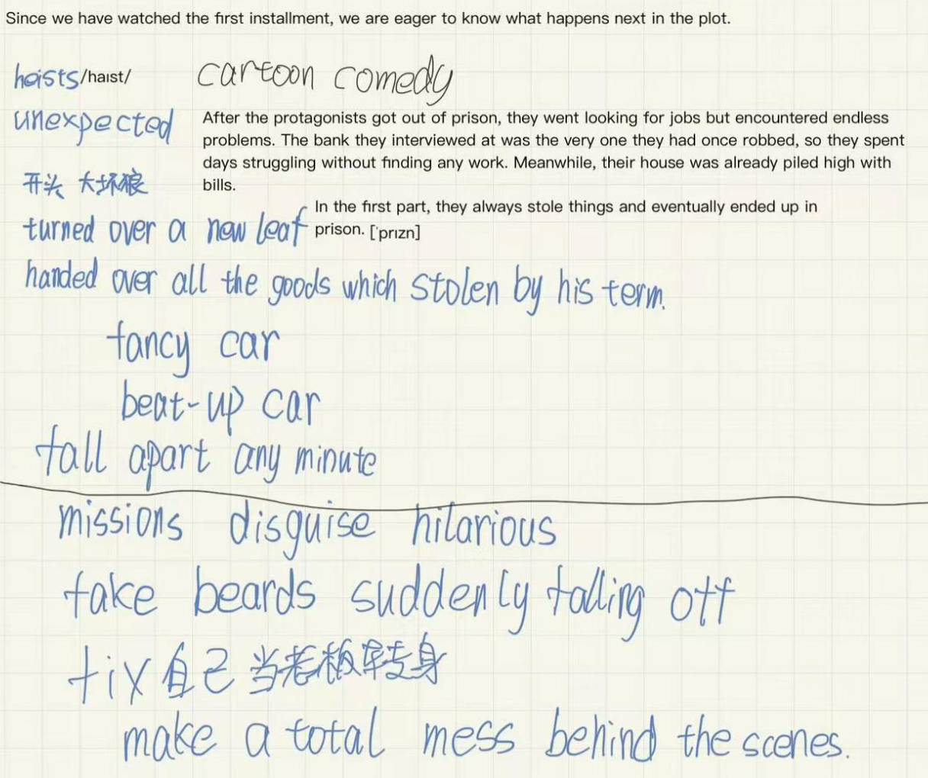
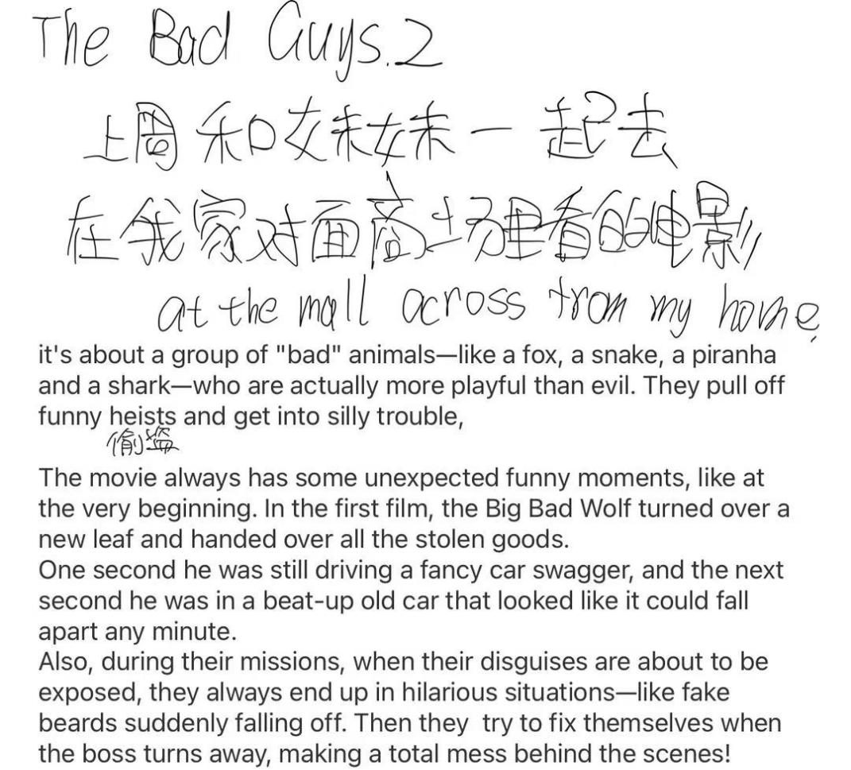

- 印象深刻的英语课
Describe an impressive English lesson you had and enjoyed
What it was about
When you had it
What the teacher did
And why you enjoyed the lesson
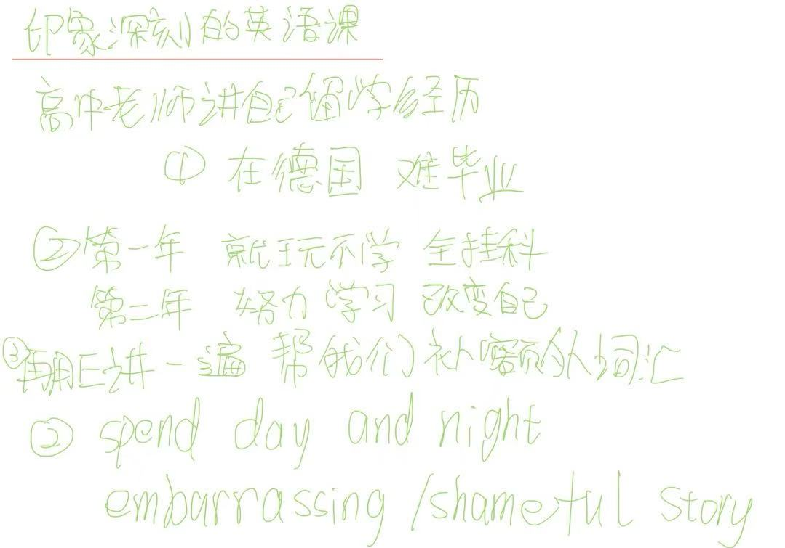

- 朋友的争执
Describe an argument two of your friends had
When it happened
What it was about
How it was solved
And how you felt about it
- 争论
Describe a disagreement you had with someone
Who you had the disagreement with
What the disagreement was
What happened
And explain how you felt about it
- 别人向你道歉（新增）
Describe a time when someone apologized to you
You should say:
When it was
Who this person is
Why he or she apologized to you
And how you felt about it

We are not allowed to delay.

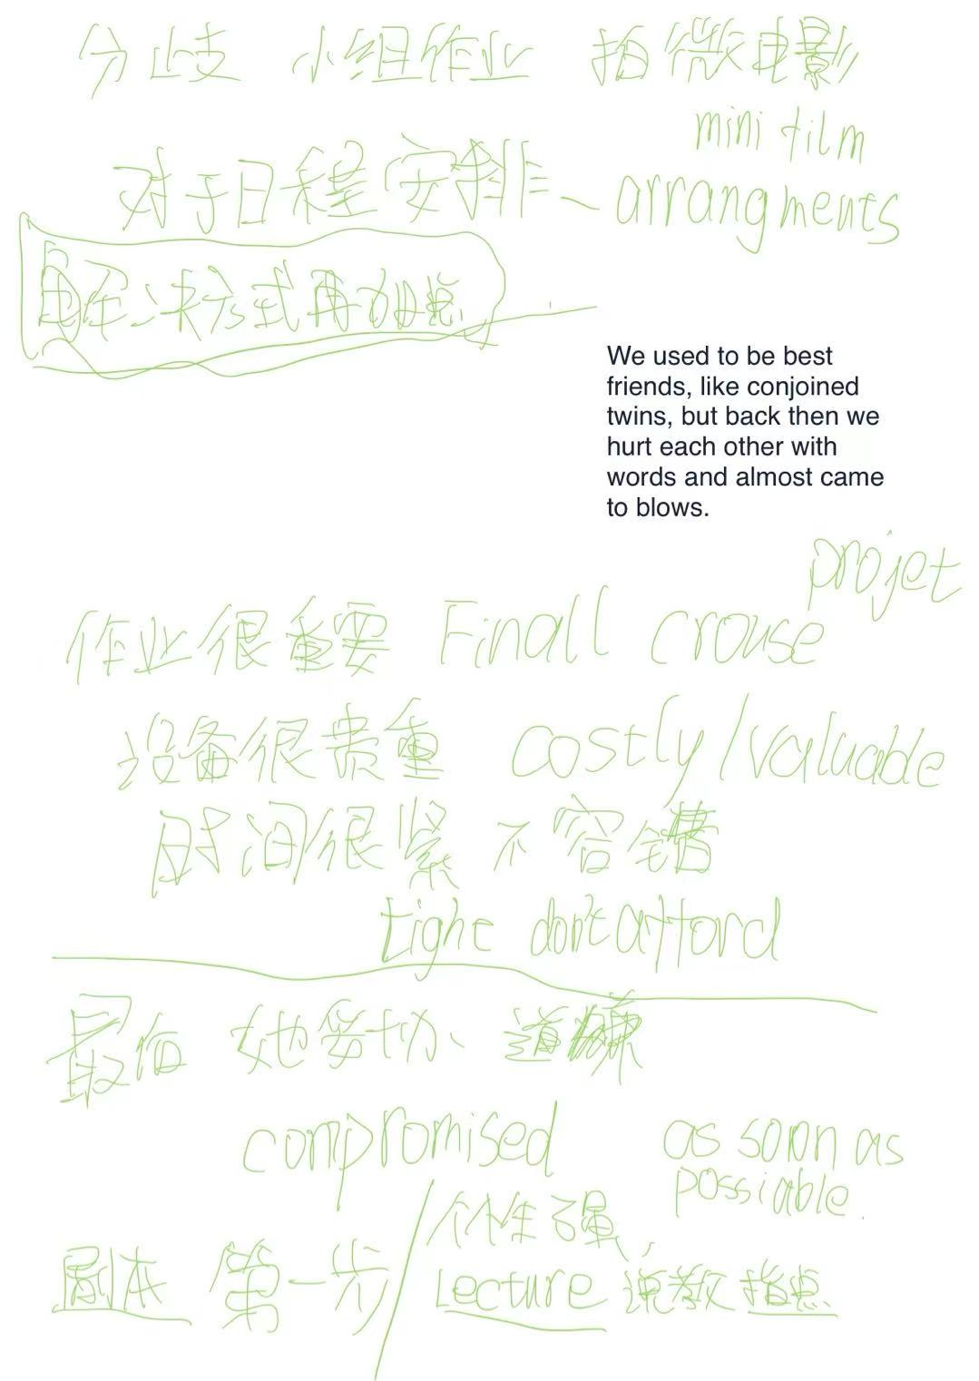

- 喜欢的节目
Describe a program you like to watch
What it is
What it is about
Who you watch it with
And explain why you like to watch it
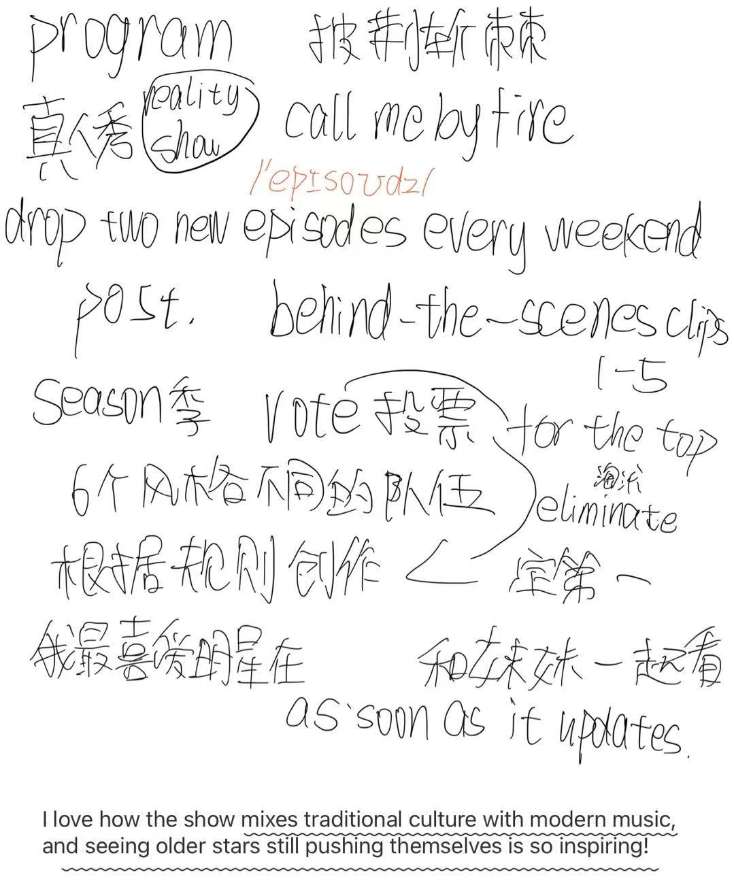

- 安静的地方
Describe a quiet place you like to go
Where it is
How you knew it
How often you go there
What you do there
How you feel about the place
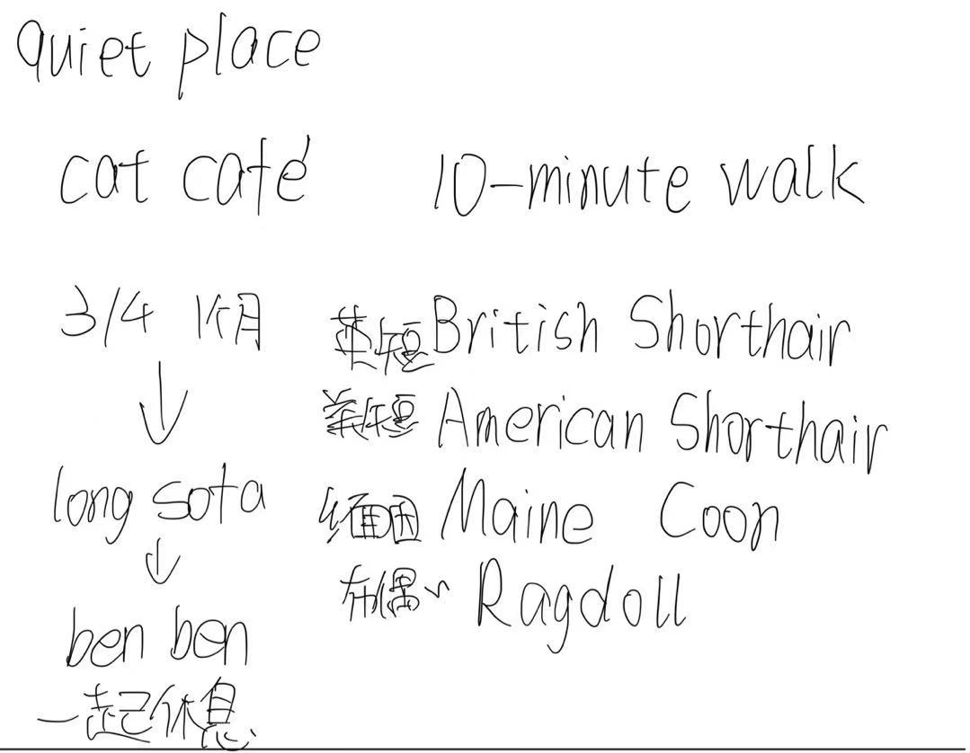

- 教别人的技能
Describe a skill that you think you can teach other people
What it is
When you learned it
How you can teach others
And how you feel about this skill
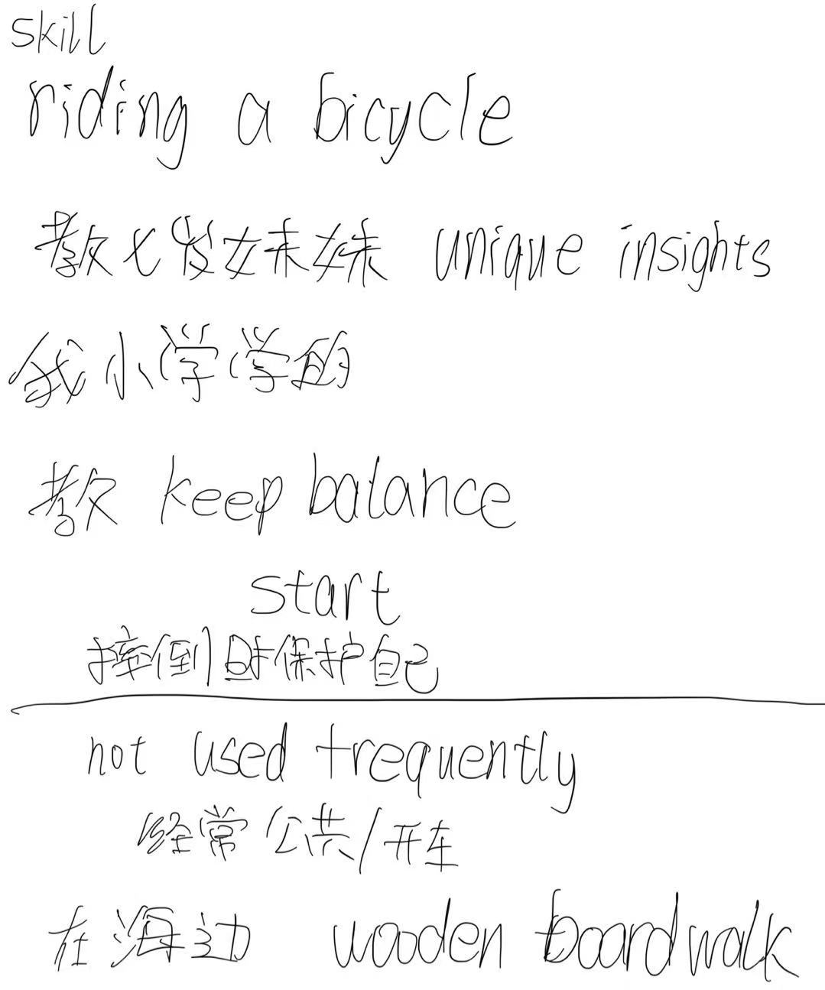

- 天空
Describe a time when you saw something in the sky (e.g. flying kites, birds, sunset, etc.)
You should say:
What you saw
Where/when you saw it/them
How long you saw it/them
And explain how you felt about the experience

- 让你自豪的照片
Describe a photo you took that you are proud of
When you took it
Where you took it
What is in this photo
And explain why you are proud of it

- 自然之地（新增）
Describe a natural place (e.g. parks, mountains, etc.)
You should say:
Where this place is
How you knew this place
What it is like
And explain why you like to visit it
- 看到动物的地方
Describe a place where you saw animals
When you went there
Who you went with
What animals you saw there
And explain how you felt about the place
- 想了解的野生动物（新增）
Describe a wild animal that you want to learn more about
You should say:
What it is
When/where you saw it
Why you want to learn more about it
And explain what you want to learn more about it
- 第一次尝试的兴奋活动（新增）
Describe an exciting activity you have tried for the first time
You should say:
What it is
When/where you did it
Why you thought it was exciting
And explain how you felt about it
- 和他人一起计划活动
Describe a time when you and some other people made a plan to do an activity
What it was
When and where you made it
What the activity was
And explain how you felt about the plan

（侧重计划 所见变为安排）

